**Referral criteria for the lymphoedema service**

**Indications for referral**

Chronic swelling linked to predisposing factors:

* Trauma and tissue damage eg lymph node dissection, radiotherapy, vein surgery
* Malignant Disease
* Venous Disease eg recurrent ulceration, post DVT
* Infection eg recurrent cellulitis, filariasis
* Inflammation eg RA, psoriatic arthritis
* Dependency-related swelling
* Primary eg hereditary, congenital syndrome

**Please consider:**

If onset of swelling is sudden, exclude presence of thrombosis or recurrent/advancing

disease and initiate appropriate action

Patients who currently have cellulitis, please refer to the BLS guidelines for management of cellulitis at:

www.wwl.nhs.uk/media/community-pdfs/BLS-cellulitis-guidelines.pdf

**Exclusion criteria**

* Non-cancer swelling present for less than 3 months – this may be caused by change in medication, trauma, infection, post op swelling or reduced mobility
* Uncontrolled cardiac/renal failure
* Superior Vena Cava Obstruction (SVCO)
* Severe vascular insufficiency
* Acute DVT
* BMI > 40 - please see flow chart on next page

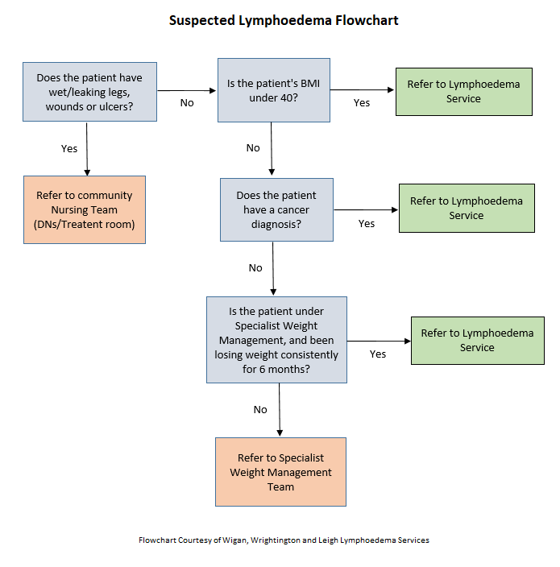**Lymphoedema Service Referral Checklist**

**Lymphoedema Referral Form**

**\*Please note the referral form must be completed – any incomplete forms will not be accepted and will be returned to the referrer \***

# Details of Illness - (please attach brief patient summary and include all relevant information e.g. letters, annotations, medications list)

|  |
| --- |
| **Patient’s details**  Surname: First name(s):  Date of birth:  **/ /**  NHS number:  Address:  GP name: GP phone number:  GP surgery:  Is the patient housebound requiring a Home Visit? Yes No  Has the patient consented to the referral? Yes No |
| **Referrer’s details (if different to above)**  Name: Designation:  Phone number: Date of referral:  **/ /** |
| **Reason for referral**  Cancer (See section 1)  Non-cancer (See Section 2)    **Clinical history/location of swelling*:** |
| **Section 1**  **Cancer details**  Is the disease active or inactive  Diagnosis: Date:  **/ /**  Surgery: Date:  **/ /**  Chemotherapy: Approximate Date:  **/ /**  Radiotherapy: Approximate Date:  **/ /** |

|  |
| --- |
| **Section 2**  **Non-cancer details**  **Please note we do not complete Doppler assessment. These should be completed before referral to our lymphoedema service.**  1. Is there any evidence of arterial compromise? Yes No  If yes, please refer to a vascular specialist and attach any documentation  ABPI right = left = Date taken:  **/ /**  2. Current BMI:  If above 40, refer to a weight management programme as lymphoedema treatment alone is likely to be ineffective in this patient group and oedema will return again swiftly if lifestyle changes are not made (British Lymphology Society’s guidelines, October 2015)  3. Does the patient have wounds/ulcers/maceration Yes No  If yes, please refer to District Nurse/Practice Nurses/Tissue Viability/dermatology as we  are not a wet leg or wound service  4. Does the patient have a history of cardiac/renal failure? Yes No  If yes, please consider referral to a specialist as we would not see patients with  uncontrolled disease. Please attach any relevant documentation  5. Is the patient able to apply compression garments independently? Yes No  If no, please ensure carers are in place to assist with this |
|  |
| **Please email completed referral form with PMH/medication records and any relevant clinical correspondence to:** [**stch.clinical.admin@nhs.net**](mailto:stch.clinical.admin@nhs.net)  Please note this is not a secure email address. It is the responsibility of the referrer to ensure appropriate measures are in place. |
| Children and out of area patients can be seen by St Catherine’s lymphoedema service, however funding would need to be agreed by their local clinical commissioning group before we are able to assess the patient. |