Job Title: | Commis Chef
Department: | Catering
Location: | St Catherine’s Hospice
Job Summary: | This new and exciting role is for an individual to assist in the provision of a high quality catering service for patients, staff and visitors to the Hospice, The Mill Café & The Mill Outside, by anticipating and exceeding customer expectations. Working with the Catering team deliver portfolio of high quality catering services in keeping with its 5 star service.  To assist the Senior Chefs on duty with storage, preparation and cooking of all food items, whilst adhering to all Health and Food Safety areas of “Due Diligence” as laid out by the hospices Health & Safety & HACCP Training Documents.
Position in Organisation | Responsible to: Food Production Manager
Contact with others
Internal – Management Team, all staff and volunteers, patients and their visitors, Professional visitors and VIP’s
External – The candidate will be expected to meet external stakeholders, suppliers and clients. Produce suppliers, Professional representatives, Workmen and contracted maintenance engineers, Statutory Inspectors

Key Accountabilities | Tasks
Finance | - To ensure the efficient & economic use is made of all resources.
Professional | - To prepare, cook and serve home-made food to meet the daily requirements of patients, staff and visitors to the Hospice and Mill Café & Mill Outside customers. This will include hot meals, soups, salads, sandwiches, desserts and specialist dietary foods, according to menu plans or daily directions.  - To learn and record skills and recipes from other members of the department.  - To prepare, cook and serve food required for meetings, special buffets and events, according to menu plans.  - To ensure that mis en place is completed as per daily production schedule.  - Assist with safe storage of all kitchen items rotating stock as per departmental procedure. Keep stores areas neat and tidy. Keep refrigeration and freezers organised.  - To ensure minimum kitchen wastage.  - To adhere to Health & Safety and Food Safety Regulations, Hospice and relevant external, policies, procedures, standards and codes of practice, and best practice in food handling. Undertake safe practice and methods of working to ensure that cleanliness and housekeeping are maintained at all times.  - Deliver a 5 star level of food and service to hospice patients and their families, Mill Café & Mill Outside customers, maintaining professionalism at all times  - To participate in departmental cleaning routines which will include, washing up, clearing food trays and stacker trolleys, work surfaces, the stove, oven and floors (this list is not exhaustive). Ensuring that records are kept of all regular cleaning and maintenance.  - To maintain kitchen equipment and the environment in a clean and safe condition and report any maintenance requirements to the facilities department  - To ensure that all areas needing regular stock check and replenishment of provision are checked accordingly to procedure.  - Provide support for volunteers working within the department to enable them to complete assigned tasks and maintain their safety.  - Make recommendations for cost savings and efficiency improvements;  - Represent the hospice at outside events and present the Catering & Hospitality department in a positive light;  - Maintaining accurate records for identifying needs for good service provision, ordering provisions and catering supplies. Ensuring that all areas requiring regular replenishment of supplies are checked and restocked accordingly.
 | - To be fully conversant with and competent to operate all systems and equipment relevant to area of work, as required after appropriate instruction. Work to existing catering policies and procedures.
Communication | - Maintain good relationships and communication with staff in all departments, volunteers, patients, customers, and board members;  - Represent the Hospice positively at outside events, meeting and functions.  - To be aware of the need to communicate with sensitivity and integrity at all times.  - To maintain patient confidentiality.  - Liaise with In Patient teams in order to identify patient needs, informing the Food Production Manager / Sous Chef as appropriate.  - Attend & contribute to regular staff briefing sessions, in order to be informed of policy, procedure or organisational change
Training and Development | - To attend mandatory training days in order to maintain organisational standards.  - Participate in annual appraisal to monitor professional performance and identify training needs.  - Undertake and utilise training and development required for the post to enhance working skills and knowledge of self to improve service delivery & customer service.

Decisions / Recommendations includes:
Decisions requiring immediate action
To support development of catering department working practice
Suggest and trial new recipes

Dimensions and limits of authority / influence includes:
Responsible for ordering consumable items within agreed limits

Allocation / checking of work
Responsible for checking that all work meets Hospice standards
Work to planned menus
Monitor own standard under direction of Commercial Catering Manager or Food Production Manager
At all times maintain statutory regulations and food hygiene best practice

Physical effort
The work is physically demanding and will include constant standing, walking, stretching, bending, moving and handling of equipment and stores. There will also be the requirement to frequently handle heavy cooking pots. Activity will continue for the whole of each shift.
The work requires speed and accuracy.
The work sometimes requires shift patterns including early mornings, late nights and weekends.

Working conditions / environment
Hot, humid conditions in the kitchen and at events for certain periods There will be use of gas and electrical equipment, industrial catering equipment, hazards in the form of wet floors and sharp implements.
The need to wear protective clothing when in the kitchen or at external events
Regular exposure to death, dying and bereavement
Daily contact with patients and relatives who may be distressed

Other Duties include:
Carry out any other duties as required by the Chief Executive, which may be required to ensure smooth running of the department in all areas. To undertake such other relevant duties and responsibilities to the grade, as may be required from time to time

Health & Safety
Comply with Hospice policies, procedures and protocols

VOLUNTEERS
The Hospice has the advantage of being supported by a number of volunteers. If a volunteer is assigned to assist you at any time, you will still retain responsibility for the requirements of this job in terms of accuracy, efficiency and standards of completion. You will also ensure good communication and be mindful of your responsibility towards that volunteer in terms of Health and Safety.

CONFIDENTIALITY
You should be aware of the confidential nature of the Hospice environment and/or your role. Any matters of a confidential nature, relating to patients, carers, relatives, staff or volunteers must not be divulged to any unauthorised person.

DATA PROTECTION
You should make yourself aware of the requirements of the Data Protection Act and follow local codes of practice to ensure appropriate action is taken to safeguard confidential information.

ORGANISATIONAL CHART (see below)
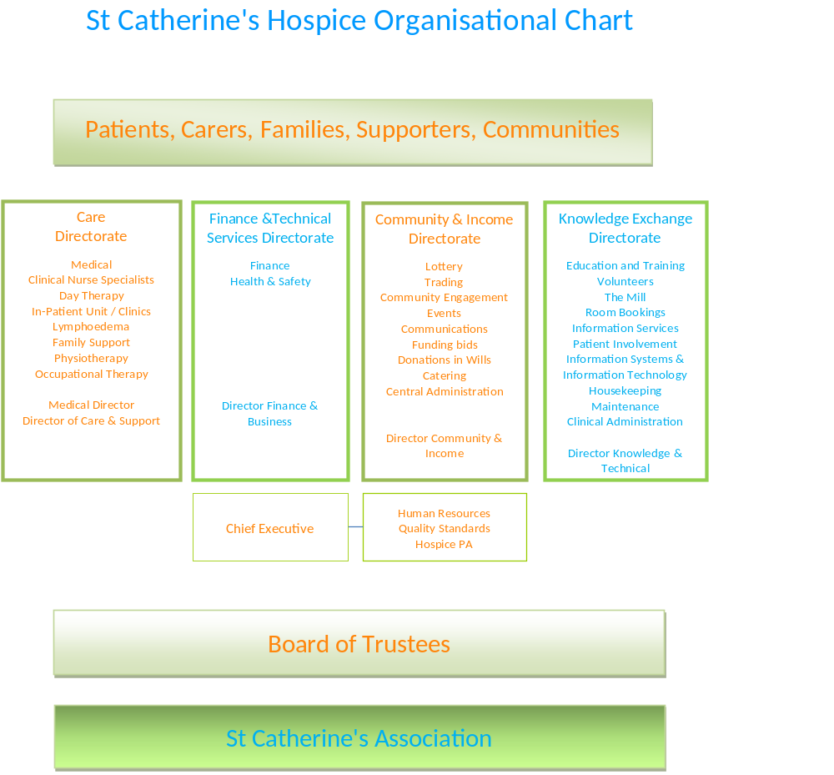

PERSON SPECIFICATION
ESSENTIAL |  | DESIRABLE
Qualifications
Basic Food Hygiene Certificate  Ability to obtain a clear DBS certificate  706/1 & 2 or NVQ 2/3 or equivalent |  | Intermediate Food Safety
Relevant Experience
Good working knowledge of the hospitality industry and HACCP and COSHH.  Able to operate kitchen equipment  Basic health & safety  Experience of all aspects of standard cooking  Experience of food regulations and controls |  | Experience in a similar catering and hospitality role within a 4 or 5 star commercial catering operation  Working in a catering operation for large events  Flair and innovative with menus and food presentation
Key Skills & Abilities
Ability to display a real passion for food and customer service  Having a ‘can do’ attitude – ability to work in a fast paced environment  Able to work unsupervised  Can accurately follow instruction  Presentable and well groomed  Good communicator with all sectors of society  Ability to listen and be sensitive  Works well under pressure and own initiative to work independently or as part of a team  Actively seeks to develop self.  Concentrates attention and activity on customer.  Excellent work record.  Attention to detail.  Professional cheerful friendly manner  Highly motivated.  Commitment to the Hospice’s Aims  Flexible with regard to working hours across a 7 day week - able to work extended hours and weekends at peak times, within reason.  Display Hospice values & behaviors at all times & actively promote them in others. | Keen to continue self-development within current role and ambition for further promotion or growth
Other
Sufficient personal resources to work effectively in a palliative care setting

AGREEMENT
Senior Manager’s name | Signature
Job Holder’s name | Signature
DATE AGREED

